**Ocean Acidification Assignment**

Purva Parmar [20181081]

**PART A**

Prepare a brief write up covering the following aspects related to ocean pH.

1. **How does oceanic carbonate buffering maintain the pH of the oceans?**

Carbon dioxide is present in gaseous state in the atmosphere. When it is dissolved in the oceans, it converts from the CO2(g) to CO2(aq) (aqueous) state.

The CO2 dissolved in this way forms Carbonic acid (H2CO3) by reacting with a water molecule.

The H2CO3 now breaks down into a bicarbonate ion.

$$H_{2}CO_{3}⇌HCO_{3}^{-}+H^{+} ---\left(2\right)$$

The bicarbonate ion now breaks down into a carbonate ion and releases another proton.

$$HCO_{3}^{-}⇌CO_{3}^{2-}+H^{+} ---\left(3\right)$$

The net result can be seen as (1) + (2) – (3):

$$CO_{2}+CO_{3}^{2-}+H_{2}O⇌2HCO_{3}^{-} ---\left(4\right)$$

Thus, when a CO2 molecule dissolves in the ocean water, it combines with a carbonate ion and a water molecule to give bicarbonate ions. These bicarbonate ions can further dissociate as per reaction (3) to give carbonate ions and protons.

Equation (4) and (3) thus describe the **Oceanic Carbonate Buffer.**

* If the pH of the ocean is increased, then we have lesser H+ ions, leading to lesser bicarbonate ions. So, now more aqueous CO2 can be associated with carbonates and water to increase bicarbonate ion concentration. Essentially, the increase in pH is opposed by taking in more CO2 and carbonate.
* If the pH of the ocean is decreased, then we have more H+ ions, resulting in the reactions in (3) and (4) shifting towards the left. The CO2 intake capacity of the ocean decreases, more CO2 is formed dissolved in the ocean. Essentially, the decrease in pH is opposed.

This buffer system helps maintain the pH of the oceans.

1. **Using Le Chatelier’s principle, explain how the pH would be altered if the CO2 concentration increases in the atmosphere.**

The answer to this follows from the coupled system as seen above:

$$CO_{2}+CO_{3}^{2-}+H_{2}O⇌2HCO_{3}^{-} ---\left(1\right)$$

$$HCO_{3}^{-}⇌CO_{3}^{2-}+H^{+} ---\left(2\right)$$

If the CO2 concentration increased in the atmosphere, it would dissolve more in the oceans, and would form more bicarbonate ions.

Increase in bicarbonate concentration means that the reaction in (2) is perturbed. To bring (2) to equilibrium again, Le Chatelier’s principle says that more products should be formed.

Hence, more H+ would form in the ocean, decreasing the pH.

Thus, **the pH of the ocean would decrease if the CO2** **concentration increased in the atmosphere.**

1. **How would a decrease in pH affect marine life and what could be the possible impact on short and long term carbon cycle?**

**Effect on Marine Life:**

Decreasing pH would mean that more CO2 is being absorbed because of higher carbon dioxide concentrations in the atmosphere.

CO2 dissolves and forms carbonic acid.

$$CO_{2}+H_{2}O⇌H_{2}CO_{3}$$

Decreasing pH would mean more carbonic acid present in the ocean. Carbonic acid reacts with Calcium Carbonate and dissolves it:

$$CaCO_{3}+H_{2}CO_{3}⇌Ca^{2+}+2HCO_{3}^{-}$$

Many marine organisms have carbonate shells, and if ocean acidity increases, their carbonate shells dissolve faster than normal.

Because of this, marine organisms would have to invest more energy and resources to form their carbonate shells, and this hinders their growth and development.

Excess ocean acidification, as it is happening right now, can then lead to deaths of marine organisms, as these carbonate shells form an important part of their bodies.

**Effect on Carbon Cycle**

The atmospheric concentration of carbon dioxide directly affects the intake of plants and hence affects the short term cycle.

In the long term, the carbonate concentration is affected in the seafloor and in the ocean.

**PART B**

1. **What is the approximate location of the data measuring station?**

The location is off the coast of Morocco, in the continent of Africa. It is present in the region of Canary Islands.

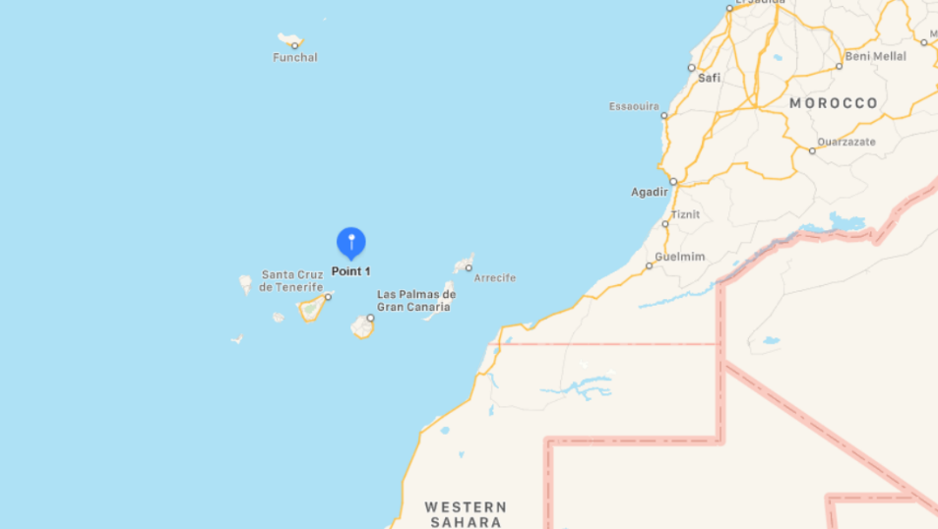

1. **Plot the variation of SST with time. Do you observe any trend in SST? What is the approximate annual range of SST? In which months do you observe the highest and lowest SST?**

SST has an oscillatory nature over the years. It has ranged from ~18°C to ~24°C.

We can get the average value of SST over each month and plot it, and we get a variation like the graph below. The error bars show the standard deviation for the values of SST in each month.

As we see, the value of SST is the lowest in January-February-March and becomes the highest in September-October.

1. **Describe how ocean pH and pCO2 have changed through time. Use your trend line to provide an approximation for how much they have changed.**

**Variation in pH**

The value of pH has decreased over time. This shows that the ocean is becoming more acidic and is going to have adverse effects.

The slope of -0.0015 indicates that the H+ concentrations have increased by about ${10}^{0.0015}≈1.00345≈0.345$% every year for the period of 15 years.

**Variation in pCO2**

The partial pressure of CO2 in the ocean has increased over time, signifying that oceans have been absorbing more of it.

The slope of 1.8905 shows that it has been increasing every year. It has almost doubled over every year, which means more and more carbon dioxide has been absorbed in the oceans, leading to greater ocean acidification.

1. **Now examine the relationship between pCO2 and pH. What can you infer about the relationship between the two quantities? Physically explain your inference.**

The graph of pCO2 vs pH is shown below. The scatter plot has been color coded with the SST values and a reference color bar is added.

Additionally, a simple linear trend line is shown. [Graph plotted in Python with matplotlib and scipy]

The trend line shows that the value of partial pressure of CO­2 increases with pH, and the slope of 45.846 shows it is a big change.

It shows that if the acidity of the ocean increased, the partial pressure of CO2 would decrease, and the CO­2 dissolving capacity of the ocean would decrease.

The color codes show the effect of temperature on the pH and pCO2 relation. It shows a different trend; as the pH decreases, the corresponding pCO­2 increases, which somehow lead to more absorption of carbon dioxide from the atmosphere.

However, we have an increasing atmospheric carbon dioxide, as seen in the general trend.

